Share a file in Teams

To send a file in a one-on-one or group chat, select Choose file beneath the compose box, select the file you want to share, and then send. You can also upload a file by going to the Files tab and clicking Share. You can select a file from your computer or OneDrive for Business account.
To share a file with your team in a channel, select Choose file beneath the compose box or go to the Files tab and select Upload.
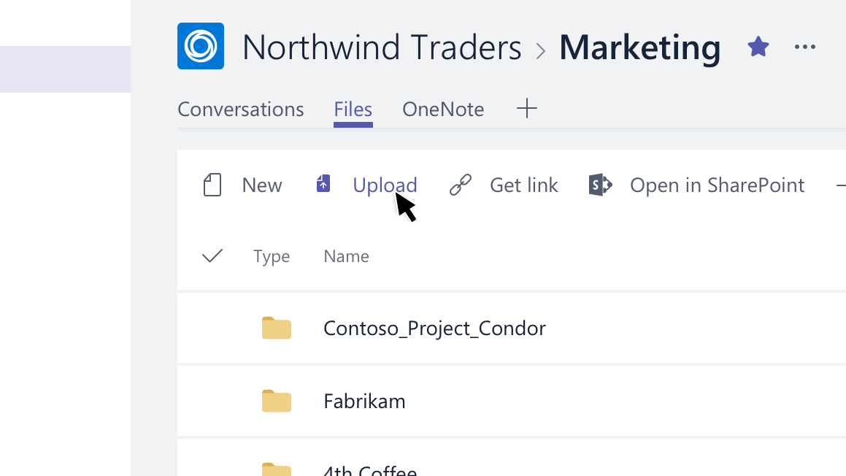
Once you share a file, you can also share a link to it. That way, you don't ever have to upload multiple copies of the same file to share it in different places.

